ML Sessional 2 Fa20 (Copy) (Machine Learning - FA20)

Points:

10/20

11,

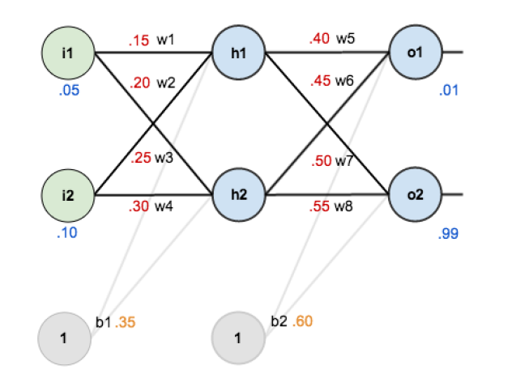

With the given values of weights and inputs. Keeping the activation function as sigmoid, what will be the input value of “h1”?. Single choice.

(0/1 Point)

0.33

0.35

0.37 correct

0.39

0.40

22,



With the given values of weights and inputs. Keeping the activation function as sigmoid, what will be the output value of “h1”?. Single choice.

(1/1 Point)

0.593

0.595

0.597

0.598

0.599

33,

Gradient Decent is used to update input values?. Single choice.

(1/1 Point)

True

False

44,

This problem (((((P v Q) v R) v S) v T) v U) v V) is a _________:. Multiple choice.

(1/1 Point)

Single Layer Perceptron Problem

Multi Layer Perceptron Problem

Linearly Solvable Problem

Non-Linearly Solvable Problem

All of the above

55,



With the given values of weights and inputs. Keeping the activation function as sigmoid, what will be the input value of “h2”?. Single choice.

(1/1 Point)

0.593

0.595

0.597

0.598

0.599

66,

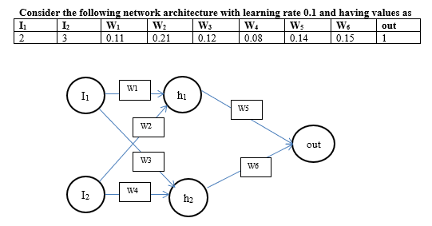

i1 and i2 are inputs, what will be the output value of h1? Take activation function as sigmoid.. Single choice.

(1/1 Point)

0.700

0.701

0.702

0.703

0.704

77,



i1 and i2 are inputs, what will be the output value of “out”? Take activation function as sigmoid.. Single choice.

(0/1 Point)

0.544

0.545

0.546

0.547 correct

0.548

0.549

88,



perform error calculations and update weight w5 using back propagation. Take activation function as sigmoid. Updated value of w5 will be:. Single choice.

(0/1 Point)

0.105

0.106

0.107

0.108 correct

0.109

99,

Logical AND with 7 variables (X,Y,Z,P,Q,R,S) is a _________:. Multiple choice.

(1/1 Point)

Single Layer Perceptron Problem

Multi Layer Perceptron Problem

Linearly Solvable Problem

Non-Linearly Solvable Problem

All of the above

1010,



i1 and i2 are inputs, what will be the input value of “out”? Take activation function as sigmoid.. Single choice.

(0/1 Point)

0.20

0.19 correct

0.18

0.17

0.16

1111,



With the given values of weights and inputs. Keeping the activation function as sigmoid, what will be the output value of “h2”?. Single choice.

(0/1 Point)

0.590

0.592

0.594

0.596 correct

0.598

1212,



i1 and i2 are inputs, what will be the output value of h2? Take activation function as sigmoid.. Single choice.

(0/1 Point)

0.615

0.616

0.617 correct

0.618

0.619

1313,

Neural nets are used for both supervised and un-supervised machine learning?. Single choice.

(1/1 Point)

True

False

1414,



i1 and i2 are inputs, what will be the input value of h1? Take activation function as sigmoid.. Single choice.

(0/1 Point)

0.82

0.83

0.84

0.85 correct

0.86

1515,

Problem of OCR can be solved using Single Layer Perceptron?. Single choice.

(1/1 Point)

True

False

1616,

It is always better to use bigger values of learning rate?. Single choice.

(1/1 Point)

True

False

1717,



With the given values of weights and inputs. Keeping the activation function as sigmoid, what will be the input value of “o2”?. Single choice.

(0/1 Point)

1.20

1.21

1.22

1.23

1.24

1818,



With the given values of weights and inputs. Keeping the activation function as sigmoid, what will be the input value of “o1”?. Single choice.

(0/1 Point)

1.50

1.40

1.30

1.20

1.10

1919,



i1 and i2 are inputs, what will be the input value of h2? Take activation function as sigmoid.. Single choice.

(0/1 Point)

0.40

0.42

0.44

0.46

0.48

2020,

MLP are always used for linearly solvable problems?. Single choice.

(1/1 Point)

True

False

[Go back to thank you page](javascript:void(0))

This content is created by the owner of the form. The data you submit will be sent to the form owner. Microsoft is not responsible for the privacy or security practices of its customers, including those of this form owner. Never give out your password.

Powered by Microsoft Forms

 |

[Privacy and cookies](https://go.microsoft.com/fwlink/p/?linkid=857875)

 | [Terms of use](http://go.microsoft.com/fwlink/p/?LinkId=2083423)